Home:
About us:
IT Services
Application Development
Application Integration
Application Support
IT Consulting
Mobility Services
Progress Services
Staff Augmentation
Testing
Enterprise Solutions:
ERP
- MFG/PRO
- SAP
- GRC Service
- Microsoft Dynamics
BI/DW
CRM
- Salesforce
Careers:
Technologies:
Clients:
Contact us:

IT Services
ATTIC provides a comprehensive range of services covering the entire software lifecycle including – consulting, development, implementation, maintenance, support and outsourcing services. We have developed stand alone software solutions as a one off engagement for clients, as well as delivered end-to-end turnkey solutions as a partner over many years. We take pride in our work and the quality of the service we deliver to our customers around the globe.

As a mature IT Services company, ATTIC approach each engagement with a “right first time” quality philosophy. We are fully committed to provide services and solutions to our customers exceeding agreed benchmarks. We build robust and reliable applications by creating an environment and framework, which foster continual improvement, tracked through our Quality Management System. We meet each challenge with the same vigour and will do whatever it takes to provide the best results for our client’s business applications.

ATTIC brings a wealth of software project innovations, excellence and proven performance. Using industry best practices, methodologies, frameworks and tools, we build world class solutions to overcome software challenges, to achieve business goals whilst mitigating cost.

We have fully secure state of the art facilities that are operational 24/7, adding to productivity with extended working hours through different time zones. We house dedicated client teams as well as customer specific ODCs.

Our global delivery model allows clients to benefit from our offshore presence whilst maintaining face to face management onshore, a typical engagement consisting of an 80/20 offshore to onsite ratio.

We offer flexibility in our engagements that are scalable to meet your operational, project and IT budget requirements and deliver a quality service with motivated and qualified talent.

Our domain experts, business analysts and architects work with business stakeholders to understand and capture the project requirements before formulating findings into a suitable design. We then deploy and deliver to agreed deadlines and focus on quality solutions and best results. Understanding your business, operations and infrastructure, allows us to offer optimal solutions that are consistent with your IT roadmap and strategies.

Application Development
Custom built software applications has been the answer to many companies who find that off the shelf products are simply not suitable or too expensive for specific needs. By choosing to develop bespoke applications for business requirements or line of service; not only can a company tailor applications to meet desired or unique operational criteria but can significantly reduce cost whilst helping to improve performance and productivity.

ATTIC have been providing world class bespoke application development services for more than two decades. Our pool of trained and certified professionals work with clients to understand their business goals, operational requirements, functionality, budgets and purpose build application solutions to meet the organisational needs.

We partner with industry leaders Microsoft, Oracle, IBM, SAP and Progress to offer an end-to-end solution aligned to your IT strategy roadmap and business goals.

We leverage our years of engineering experience to deliver robust solutions to our customers. We use a mix of development methodologies such as Agile, RUP, TDD, Iterative and Waterfall development that best fit the client engagement and deliver best return on investment. We pride ourselves on delivering high-quality, reliable and flexible applications that are easy to maintain and facilitate enhancements.

We have developed a range of custom applications for many industry sectors including: B2B & B2C Portals, Billing System, Record Management, Logistics Management, Pharmacy Administration, Payroll and Tax systems, HR Management, MIS, Accounting, Oil retailing, Pension Administration, Car and Hotel rental and custom ERP’s.

Our services and solutions are tailored to match your unique business need and IT requirements because we believe there in no ‘one size fits all’ approach. Our clients, whether a large enterprise or small Independent Software Vendor (ISV), all benefit when they partner with us.

Our application development service includes:
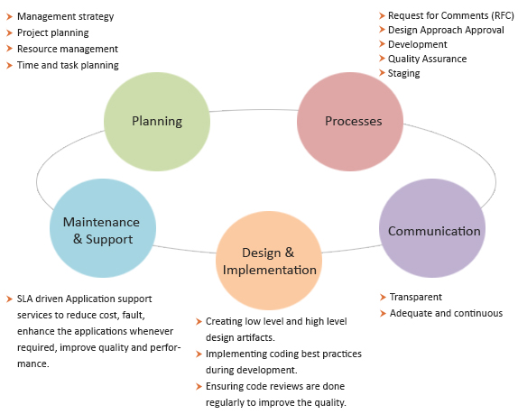
End-to-End Custom Applications Development
Our custom applications development services comprises of complete software development lifecycle from business requirement analysis, plan, design, development, testing, deployment and warranty support of the application/product. Using industry best practices, methodologies, tools, collaborative techniques and our robust development processes, enablers we help our customers quickly & efficiently build, deploy and manage high quality applications / systems. We lay great emphasis on superior design, usability, portability and overall user experience so that our customers stay ahead of competition. Our custom applications development service offering consists of:

- Process & Governance Assessment
- Project Management and Execution
- Reengineering
- Character, Client-Server GUI, and Web based development
- Portal Development
- Component-based Distributed Application development
- Open, standards-based Interoperability and Integration
- Improving application performance and scalability
- Implementing multilingual capabilities

Application Platform Migration
We have provided migration services and done successful migration of application, database and business logic layer to the open and proprietary platforms like Java, DotNet, Oracle, ERP systems. We provide an end-to-end service ranging from feasibility and gap analysis to production rollout and operational handover. Our application platform migration offering consists of:

- Assessment of current application and new platform gap analysis
- Licensing and pricing recommendation
- Application analysis and change identification
- Execution and rollout planning
- Partitioning of business logic from existing application and specifications creation
- Design changes in business logic for reuse
- Development of UI design and backend processes
- Validation testing (Integration, regression, Performance, UAT)
- Rollout and production handover

Application Modernisation
Our application modernisation solution is designed to increase the shelf-life of your current applications leveraging the advancement in technology, at a fraction of the cost. We understand that your core systems are mission critical and have been running successfully over many years. You would like to take it to the next mile without attempting any significant changes to the current functionality or compromising performance. In the process of doing so you may not be willing to change or rewrite your existing system on new platform. With our proven expertise to modernize the applications for our clients we have added many more years of shelf life to several ISV products and end-user in-house custom applications. Our application modernisation offering consists of:

- UI development on Web
- SOA implementation
- Middleware implementation for enterprise level integration
- Cloud , SaaS, PaaS enablement
- UI development on Mobile (Andriod, iOS, Blackberry, Symbian, Windows)
- Integration of off-the-shelf Business Intelligence and data warehousing product with your existing application.
- Implementing 3rd party reporting and analytics solution with your existing applications
- Database Services (Oracle, SQL Server, Progress)

Application Integration
Enterprises today are constantly looking at ways to get the most from their existing applications/ systems, whilst wishing to improve performance and cost. Enterprise Application Integration(EAI) enables integration of your disparate enterprise software assets in order to leverage their collective benefits to your business needs. A right EAI implementation helps your organisation achieve various key business goals, such as an increased interaction within disparate systems and departments, increased agility, reduced operational costs, easier enterprise asset management, and overall, an increased return on investment.

An EAI solution not only ensures consistency of information generated across heterogeneous systems, it also makes your enterprise architecture vendor-neutral. A successful EAI implementation reduces the impact of software/vendor changes on your business continuity. EAI also offers a single point of access for multiple integrated applications to reduce learning curve for users and to minimize latencies in the information flow across systems. This, in turn, results in a potential reduction in the operating costs incurred in usage of your enterprise software.

At ATTIC, we have led numerous successful implementations for our clients with our time-tested EAI solutions approach. ATTIC provides a range of services woven around facilitating seamless integration between existing application portfolios. Also, we help extend your organisation’s capabilities to integrate its software with its business partners, suppliers, vendors, and customers.

ATTIC specializes in developing and managing robust EAI solutions. With each EAI project, our EAI solution experts collaborate to identify key business goals, define the optimal solution, and manage the project through to a successful implementation with a thorough understanding of industry standards, best practices, and technology. As a result, we help our customers in lowering down the cost of ownership and time-to-market for their new applications.

Our portfolio of Enterprise Application Integration services includes:
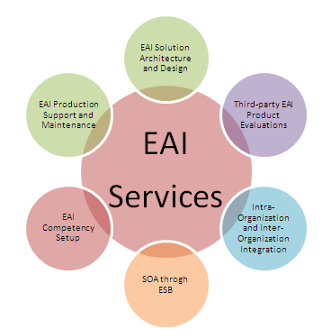
- EAI solution architecture and design:
- Third-party EAI Product Evaluations:
- Intra-Organisation and Inter-Organisation Systems Integration:
- Enabling SOA through Enterprise Service Bus (ESB):
- EAI Competence Setup:
- EAI Production Support and Maintenance:
- How ATTIC leverages its EAI strengths

Application Support
Over the lifecycle span of software applications, nearly 70% of the cost goes into Application Support & Maintenance activities. Minimizing the total cost of maintenance and support has a direct impact on operational expenditure OPEX and business value. ATTIC aims to maximize this business value through a slew of highly effective, focused and scalable maintenance and support services.

We understand that every client is unique and so are their requirements. Our proven methodology and global delivery model is well equipped to help enterprises maximize the output from their investments. Recognising the challenges associated with maintaining and managing applications, especially where core business processes are involved, ATTIC combines critical business understanding with cutting edge technical skills to provide seamless and integrated application maintenance and support.

ATTIC has proven experience in delivering remote offsite / offshore support (8×5 or 24×7) to businesses around the globe using best industry processes. Our ITIL aligned and AMS certified processes offer flexibility to provide quality support to businesses of any size.

We offer flexible engagement models to suit your business requirements and budgets. We seamlessly integrate with your support organisation to offer a great support service to your customers. Our fully documented processes, tools and transparent communications help us to exceed the defined service levels (KPI’s) within a short space of time whilst we deliver a great value using our global delivery capability.
Our portfolio of the application support services include:
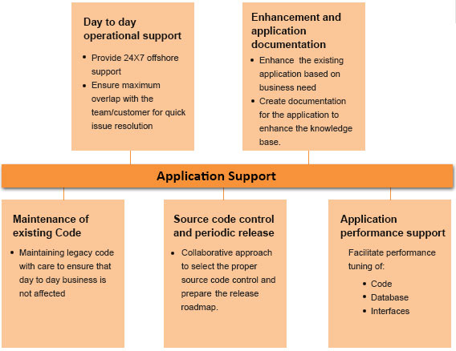
- Maintenance of Existing Code:
When your applications have years of legacy code, it becomes a challenge to maintain the code. Nonetheless the code holds important business logic which is core to your operations/ business. Any disruption to the day-to-day business is not acceptable so code maintenance becomes a key task to make sure business does not get affected by any change. Our years of experience in maintaining the legacy code will free up your key IT staff for other activities of importance.
- Day-to-Day operational Support:
We will structure our support to provide your application/customer the maximum overlap and we can work as extension of your team where we will take calls from your customers, perform a quick analysis and carryout the call resolution which are smaller in nature. For bigger resolution we will get your approval and carry out the resolution based on priority.
- Source code Control and Periodic release:
We will structure our support to provide your application/customer the maximum overlap and we can work as extension of your team where we will take calls from your customers, perform a quick analysis and carryout the call resolution which are smaller in nature. For bigger resolution we will get your approval and carry out the resolution based on priority.
- Add-ins Development and Application Documentation:
To support your day-to-day business and to address your customers’ requirements, add-in or enhancement to existing applications functions are integral part of application support. We will work with you to detail out the design approach, get it estimated and work upon the add-in as per the priority.
One of the most common issues with old legacy application is lack of documentation. If you are planning to retire your application or if you are planning to modernize your application then the importance of documentation cannot be overlooked as induction of any new team member will need documentation. We can undertake the documentation of your applications, systems, architecture, business processes or even a specific module. We have structured documentation template to record application documentation.

- Application Performance Enhancement
A legacy codebase often has gone through numerous code changes, refactorings, and sometimes, hasty code additions with zero or insufficient documentation. This results in gradual performance deterioration and leads to cost overheads incurred in maintenance. Also, over the years when data volume increases, some business logic which earlier used to perform as per expectations, becomes slow. We will analyse the specific portion of application, devise the performance enhancement solution, recommend multiple options, and work with you to achieve the desired results.

IT Consulting
Businesses, today, are faced with one of the worst economic climates for decades. The need to stay on top of costs and maintain/ improve business services is fundamental to sustained success. The burden and pressure this creates for IT is unparalleled in recent years. Having the correct strategy, applications, technology and services partner is paramount to meet the demands of business if IT is to control budgets and maximise any investment.

ATTIC’s IT Consulting Services help our clients overcome these challenges and deliver integrated, end-to-end IT solutions and services to help your business move in the right direction.

Our IT consulting services includes:
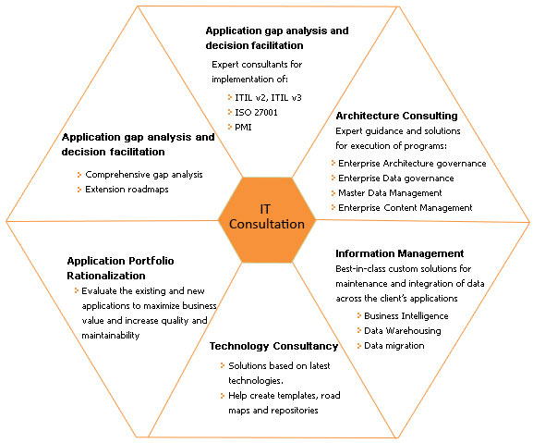

- Process Consulting:
- Architecture Consulting:
- Information Management:
- Technology Consulting:
- Application Portfolio Rationalization:
- Application Gap analysis and decision facilitation:

Mobility Services
Mobile Capabilities

Services Offered
- Mobility – Application Architecture & Consulting
- Native application development on iOS, Android, Windows, Blackberry
- Common device application development in HTML5
- Application development with SAP development tool set
- Integration with enterprise applications, e.g. SAP, Salesforce, Mfg/Pro etc.
- Integration with application development in technologies, such as .NET, Java, Oracle
- Web services creation
- Human Interface Guidelines application
- Team well-versed with Human Interface Guidelines for each platform to offer the best in class applications for each handset
- Storyboard creation >> Wireframes >> Graphics >> Development >> Release

Smart Phone Application Development:
ATTIC has expertise in SmartPhone Application Development, iPhone Game Development and Custom Mobile Application Development. We design, develop & deploy successful applications for multiple platforms like iPad, iPhone, Blackberry, Nokia & Android. Our mobile applications evangelists help convert an idea into a real application. We help define the features & navigation to best suit the business, target audience of the application as well as the target device.

Progress Services
ATTIC is one of the industry’s leading providers of Progress Software services with more than two decades of experience, providing application development and support to customers globally. Our association with Progress Software Corp. (PSC) started in 1988 and continues to flourish today.

ATTIC’s Progress practice comprises of over 150 trained consultants which makes us one of the largest Progress specialists in the world in ‘Core’ Progress OpenEdge development skills.

We have a proven track record in providing services on platforms including Linux, Unix, AIX and MS Windows across all Progress versions starting from V5 as well as Character, GUI, Web based and Mobility solutions. Our mature Progress practice has robust and time tested methodology, solution delivery framework and capabilities that ensure the best solution for our clients. We partner with industry’s leading technology providers such as Microsoft, Oracle, SAP and IBM to ensure that all your enterprise integration requirements are well serviced under one roof.

Having delivered solutions in Progress technology to ISV’s, SME’s and many large enterprises across the globe over many years, we have earned an industry reputation as a reliable Progress Software services partner of choice. We have extensive experience in leading Progress based solution such as QAD, Infor Syteline, NxTrend, Epicor, MXP, FACTS, Dispatch-1, OpenAccounts, k-PAYE, Geneva, iCON, IRMS, SAGE.

Our portfolio of Progress service offering includes:
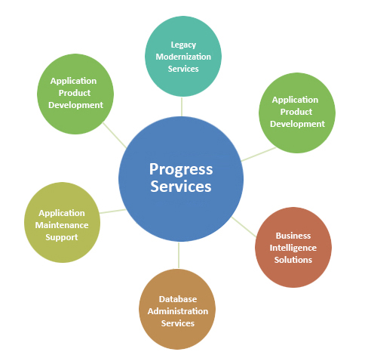
- Legacy Modernization Services
- Application/Product Development
- Application Maintenance and Support
- Business Intelligence solutions
- Database Administration Services
- Progress Corticon
- Training
Staff Augmentation
ATTIC’s Staff Augmentation services offer trained, certified and experienced software professionals at a highly competitive rate. We work as an extension of your IT team either onsite at your location, or off-site at one of our delivery centres under your supervision or managed by ATTIC.

We have assisted many clients across the globe from Xerox, Unilever, Ford, Boots and Specsavers to SME’s and ISVs and have built an enviable reputation and relationships spanning many years.

We understand that success of any staff augmentation service is based on providing well trained individuals with the right skills at the right time to suit your IT demands. We take a collaborative approach to plan your skill requirements for the duration of your project and ensure proper on-boarding of individuals or team. Based on your resource forecast and project requirements our flexible approach allows
you to ramp up or ramp down the resources or change the domain skill set at any point of time. So whether you need an individual or team of dedicated additional resource ATTIC can help.

We combine our global delivery capability with flexible engagement models to offer a custom solution to suit each client’s project requirements and budget. We allow our clients to change the delivery structure to capitalise from our offshore presence and also transition to a fixed or output based model to meet client’s business demands.

Staff Argumentation Life cycle:
We ensure client satisfaction by providing motivated, certified and skilled resources and deliver a high quality service. We create an open dialogue with clients and have regular feedback sessions to monitor each engagement. These sessions allow ATTIC to track staff productivity, performance, adaptability, attrition and take corrective / preventive actions to de-risk any issues during the client’s project. If any resource does not meet the client’s requirements we assure staff replacement at no extra cost.

As a true IT services, we also bring a wealth of experience in software applications development, processes, methodologies, best practice, domain and technical expertise to each engagement which increases performance and is a great value addition to clients.

ATTIC has a pool of certified consultants across leading technologies such as Microsoft, SAP, Oracle, IBM, Progress and other packaged industry solutions. We offer our customers a broad range of skills at various experience levels including:

- Web developers, Software Engineers, testers, UI designers
- Business Analysts, Project managers, Solution Architects, Technical leads, Integration experts
- Help desk staff, support analysts, delivery managers, DBA’s
- Functional/technical experts in SAP, QAD and Oracle across industry domains
- Salesforce.com, Pentaho, Epiphany, Business Objects
- Mobility domain developers
Benefits from ATTIC’s IT Staff Augmentation services:
- Certified and experienced personnel
- Flexibility to switch the domain skill set in line with clients IT software services needs
- Scalability to ramp up or down to meet clients project needs
- Support of a fully developed knowledge base and infrastructure
- Advantage of skilled dedicated manpower at a very competitive price
- Flexible engagement models to suit clients changing business situation
- Client or ATTIC Managed option
- Best engineering practices of ITIL, PMP, Prince2, Agile & TDD
- Continuous training programs and up-to-date on leading technologies

Testing
With the ever-increasing reliance of business-sensitive activities on IT systems, quality of software has become one of the most important goals of IT departments. In order to effectively address the challenges involved in quality management and testing, ATTIC offers an exhaustive array of services in the arena of testing. Our testing services have evolved in order to help you achieve your software quality objectives in the most cost-effective and timely manner.

Backed up with two decades of rich software development experience, our independent testing services employ sharp technical resources, industry-recognized tools and utilities, adequate infrastructure assets, and proven quality processes. Our CMMi and ISO-compliant testing processes have been matured to ensure delivery of repeatable and measurable results with each of our engagements. At ATTIC, we have developed expertise in testing services across various business verticals.

Our portfolio of independent testing services includes:
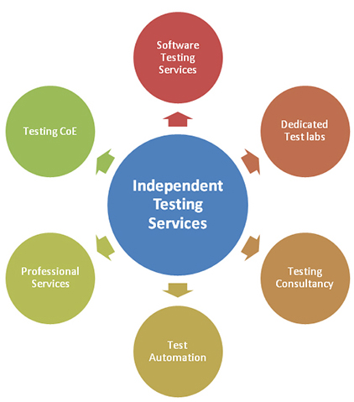

Enterprise Solutions
ATTIC Enterprise Solutions has a sharp focus on designing solutions for your business success by developing a deep understanding of your business challenges and industry environment. Our technical know-how, domain knowledge and delivery experience has been encapsulated in a holistic framework that we call the Business Transformation Framework. This framework brings together industry knowledge, application knowledge and delivery experience into a single framework where proper balancing of three aspects is ensured for delivery of world-class solutions and services consistently. Principal pillars of this Business Transformation Framework are:

- Industry specific business process models and accelerators
- Application lifecycle and context specific execution methodologies
- Business problem specific solutions and enablers
ATTIC provide solutions for MFG/PRO, Salesforce.com, Epiphany and are accredited partners with industry leader SAP and provide solutions to our clients covering the entire lifecycle of Enterprise application – from ERP selection, implementation, upgrade and enhancements to maintenance and support.

ERP
Enterprise Solutions: Overview
In today’s fast moving, global economy organisations are utilizing Enterprise Resource Planning (ERP) systems as the backbone of all business transactions and communication. ERP systems have evolved from being a core transaction processing platform to become the launch pad for B2B commerce and growth management.

ATTIC are at the forefront of ERP solutions, providing exceptional services aligned to the IT needs and business goals of our clients around the world. We have extensive experience in successfully deploying, managing and delivering world class solutions utilizing our global delivery capabilities which enables us to deliver a first class service whilst mitigating cost.

Our Enterprise solutions include:
- ERP Consultancy
- Design
- Implementation
- Migration
- Upgrades
- Roll-out
- Mobility
- Maintenance, Support
- Managed Services

Designed to maximize the value of ERP implementation, our services leverage domain expertise to deliver targeted solutions to our clients across a number of industry sectors.

ATTIC Enterprise Solutions has a laser sharp focus on designing solutions for your business success by developing a deep understanding of your business challenges and industry environment and is committed to delivering value for money services and solutions that help your operations respond to dynamic business environment and needs.

With change being the only constant in today’s business environment, ATTIC has designed a comprehensive Business Transformation Framework to deliver its services that help in our client’s business growth and profitability. Our suite of Enterprise Solutions Services are designed to partner with you for the entire lifecycle of your enterprise applications as they evolve. We have proven capabilities and demonstrated experience in servicing our customers right from a greenfield implementation to rollouts & upgrades or implementation of enhanced functionalities and add-on products based on the business requirements.

Our global delivery capabilities, advanced development centres and offices across the world together with the most up-to-date infrastructure, tools and certified talent pool enable us to deliver best-in-class offshore services along with the benefits of a low cost execution, world class expertise and a flexible partner. Our deep belief in the ability of domain knowledge to add value to services and solutions being delivered to customers has been emphatically demonstrated in our execution of several platform refurbishment and change projects for some of the leading names in the global market place.

MFG/PRO
ATTIC is one of the largest MFG/PRO service providers in Asia, with a strong track record of servicing MFG/PRO clients across countries like USA, UK, Australia, Japan, Srilanka and Canada. ATTIC specializes in providing Production Support Services from off-shore and have been highly successful in handling customer’s engagements both onsite and off-shore. We have a robust and scalable methodology to meet our client needs and associate with them as long term IT partners for their on-going business requirements.

Versions
- MFG/PRO Ver. 7.x to eB2.1 (CUI/GUI,.Net UI)
- Progress Ver. 9 to OE10 (CUI/GUI), ADM1, ADM2, Web Speed
Modules & Specializations
- Standard QAD Modules
- APM – Advance Pricing Module
- EDI E-Commerce
- AIM – Advanced Inventory Management

MFG/PRO Service Offerings
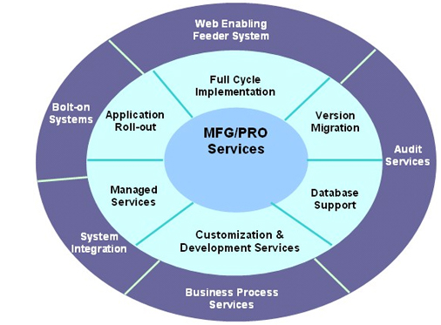

Services Catalog
- Full Cycle Implementation with Post Implementation Support
- Version Migrations
- Application Rollouts (Multi Site/Multi Country)
- Production Support
- Bolt on Application Development with MFG/PRO as the backbone
- Development of Extranet applications which can integrate with MFG/PRO applications using .Net/Java based framework
- Remote DBA support services
- Application Audit Services
Services:
- Full Cycle Implementation with Post Implementation Support
- Customizations & Interface
- Version Migration
- Application Roll-out
- Application Support
- EDI Services
- MFG/PRO to SAP Migration
- Remote DBA support services
SAP
ATTIC as an ERP Centric Organization has identified SAP Services as one of its Key growth enablers by these stated objectives for SAP

- To provide continuous Value addition to our clients through our robust processes, methodologies and services assurance model.
- To have the right talent, experience and nurture them, as they play an instrumental role in the growth of the organization
- To give total focus to customer, invest and build the right services and people, to sustain and grow the engagements
ATTIC forged its strategic Partnership with SAP India in 2007. We have strengthened our relationship and have demonstrated significant amount of involvement in leveraging this partnership. We are partners with SAP in distinct categories’ which helps us to position our service offerings and provide value based on their business needs
SAP Services Partner: It provides a competitive advantage to offer collaborative solutions to large corporations in India. The partnership enables us to acquire latest SAP offerings, which in turn helps us to provide value to our customers.

SAP Services Catalog
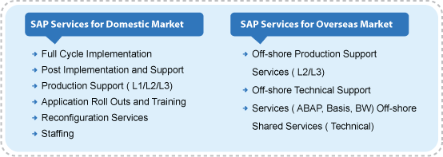

SAP Competency – Module expertise

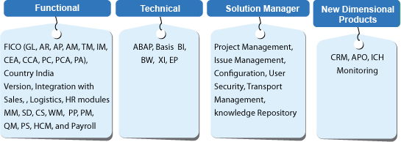

SAP GRC Service
We at ATTIC offer a comprehensive suite of SAP GRC services to meet every need of our clients. We have a proven track record in managing & successfully delivering offshore / onsite projects. Our flexible and adaptable delivery model has been designed to suit the time, quality and budget demands of our customers. Our service offerings are as mentioned below:
Services:
- Compliance and Security Audit
- Authorization Management
- Risk Management
- Access Control
- Process Control
- Mobile Applications

Microsoft Dynamics
Why Growing Education Need ERP?
Education Institutions of today is expected to be extremely nimble, so as to catch up with the increasing demands of stake holders. In a highly digital world where bright, wise brains teach young and fresh minds, sky becomes the limit for what can be achieved through information technology. IT today has in its arsenal varying and rapidly evolving technologies, which can be leveraged to provide real time information at a click of a button.

ATTIC with its vast experience in providing ERP services ,brings forth a rapid scalable solution to Education market combining ERP with state-of-the-art Mobility and Cloud technologies .ATTIC offers a suite of products built on top of Microsoft’s NAV ,thereby ensuring that the investments are well protected and insured against legacy systems.

Our rapid solution not only improvises the capabilities of education institutions but also supports in running critical processes such as:
- Enrolment management
- Application processes
- Student information system
- Integration and optimization
- Institute Operations

BI/DW
BI (Business Intelligence) is a term commonly associated with DW (Data Warehousing). In fact, many of the tool vendors position their products as business intelligence software rather than data warehousing software. There are other occasions where the two terms are used interchangeably.

BI is the ability for an organisation to take all its capabilities and convert them into knowledge, ultimately, getting the right information to the right people, at the right time, via the right channel. This produces large amounts of information which can lead to the development of new opportunities for the organisation. When these opportunities have been identified and a strategy has been effectively implemented, they can provide an organisation with a competitive advantage in the market, and stability in the long run.

BI also refers to the information that is available for the enterprise to make decisions on. A data warehousing (or data mart) system is the backend, or the infrastructural, component for achieving business intelligence. Business intelligence also includes the insight gained from doing data mining analysis, as well as unstructured data (thus the need for content management systems).

BI technologies provide historical, current and predictive views of business operations. Common functions of business intelligence technologies are reporting, online analytical processing, analytics, data mining, process mining, complex event processing, business performance management, benchmarking, text mining, predictive analytics and prescriptive analytics.

ATTIC BI experts have delivered end-to-end solutions for many global organisations that consider their customers as one of the foundation blocks for their business. Our BI teams not only consist of the experts in implementation of third-party software, but also are capable of developing the completely custom-tailored BI software for addressing the unique needs of your business.

ATTIC with experience in establishing and streamlining our clients BI requirements across the globe has created a mature leading BI/DW practice enabling our customers to take informed business decisions. Our BI/DW practice has matured over the years and now offers solutions in most industry’s leading technologies Microsoft, Oracle, SAP, Business Objects, Pentaho and Qlikview.

Our services offering in the BI / DW area consist of:
- BI Strategy development & product selection
- KPI design
- Enterprise BI Lifecycle Implementation
- Data Management / Warehousing / OLAP
- Data Quality / Data Mining / ETL
- Reporting service & integration
- BI Training
- Upgrades & Migration
- Maintenance & Support

CRM
CRM (Customer Relationship Management) is a widely implemented model for managing a company’s interactions with customers, clients, and sales prospects. It involves using technology to organize, automate, and synchronize business processes—principally sales activities, but also those for marketing, customer service, and technical support. Ever changing business dynamics and global competition requires constant evaluation and enhancement of CRM application strategy.

ATTIC have over two decades of experience in establishing and streamlining our client’s CRM requirements across the globe including- new CRM implementation, third -party CRM solution, supporting existing product or analyzing and enhancing the application.

Our CRM practice encompasses all aspects of an organisation’s engagement with their customers. For instance, in order to boost your sales and exposure to a wider customer-base, we help you build and leverage your social presence using the social network CRMs. On other instance, we help you gain advantage of the inbound and outbound modes of marketing utilizing various marketing channels, such as mobile phones, e-mails, traditional mails, websites, micro-blogging and social networks. Our service offerings include complete implementation of marketing campaign management over all the marketing channels available today.
Similarly, for a great customer experience, we implement the CRM-driven storefronts that are integrated with the remaining components of the CRM. In order to help you optimize the after-sales and customer support processes at your organisation, we implement special CRM modules for contact centre management, voice support, technical support, and the relevant workflows.
While developing the CRM solutions, we constantly focus on giving your internal teams and your customers the most simplistic and holistic view of the complex CRM scenarios. For instance, we help your workforce gain a 360 degree aerial view of all the customers, their product profiles, vendors, suppliers, and partners. At the same time, we also enable you to compute your ROI, view customer trends, and perform business-specific analytics.
Over the years, we have completed several CRM implementations using the most popular tools, including Salesforce.com, Infor Epiphany, SAP CRM in Retail, Travel, Consumer Goods, Manufacturing and Automotive industries. Our CRM teams have also developed custom CRM solutions for addressing the unique needs of our customers including, customized Apps on Salesforce.com
- Storyboard App – gives 360 view on an Opportunity / Account
- Part / Item Configurator App – lists product details
- Campaign Sharing App
- Product Forecast App
We have successfully helped our clients enhance their customer engagement, increase the overall satisfaction levels amongst their customers, and thereby, maximize their ROI (Return on Investment).
Our CRM solutions and services portfolio consists of:
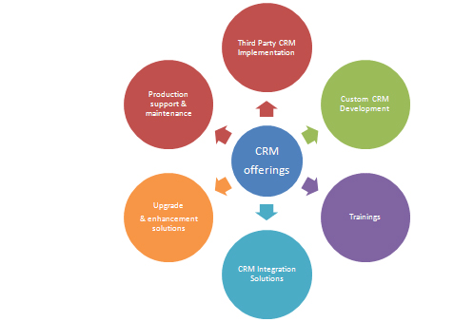
Services:
- Third party CRM implementation
- Custom CRM development
- CRM Integration solutions
- Customer centric upgrade and enhancement solution for existing CRM system
- Managed service / Production support
- Trainings on CRM

SalesForce
About Salesforce:
Salesforce.com is the worldwide leader in on-demand Customer Relationship Management (CRM) services. More companies trust their vital customer and sales data to salesforce.com than any other on-demand CRM company in the world.

It delivers integrated, completely customizable enterprise applications for companies of all sizes. Salesforce is easy to learn & use and due to the power of the on-demand Force.com platform, it can be up and running in weeks or days—not the months or years required by traditional client/server CRM software.

The proven leader in on-demand Customer Relationship Management (CRM), salesforce.com empowers customers to stand out from the crowd. Salesforce’s solutions combine award-winning functionality, proven integration, point-and-click customization, global capabilities, and the best user experience and the result is CRM success. All these factors have enabled Salesforce to earn the trust of its customers and a customer success rate of 95%*.

Role of ATTIC:
ATTIC is Cloud Alliance Consulting Partners with Salesforce.com. ATTIC’s expertise, experience, and abilities, combined with the robust technology and rich out-of-the-box solutions and certified resources on SF.com is providing meaningful benefit to the customer. Cost effective solutions based on the on-site & off-shore and mixed models of delivery, and an insightful understanding of client business goals and requirements, has translated into long lasting relationship with clients. ATTIC is proud of the strong and fruitful relationships it shares with each of its clients.

